**RAILWAY GATE AUTOMATION**

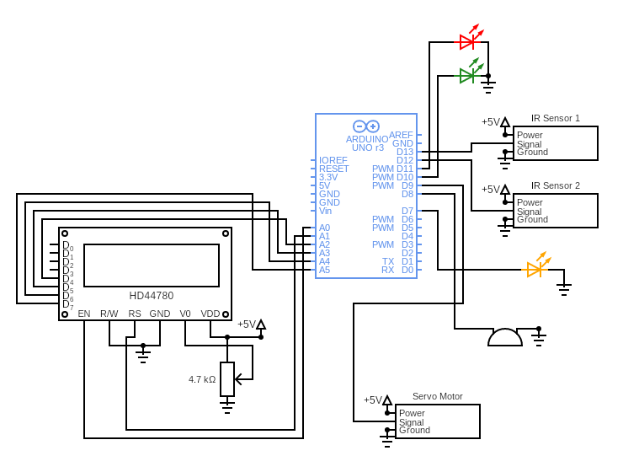

**Working of components**

**Arduino UNO Board:**

The user can get started by connecting the Uno to a computer with the USB cable or by powering it with an AC / DC adapter or battery. The Uno can be programmed with Arduino Software (Integrated Development Environment). Arduino Uno features 14 digital input / output pins (six of which can be used as PWM outputs), six analog inputs, and a 16MHz quartz crystal. Uno also includes a USB connection, a power jack, an In- Circuit Serial Programming (ICSP) header, and a reset button. This Arduino MCU board contains everything the user needs to support the MCU.

**16x2 LCD:**

The LCD module is in connection with D8 to D13 pins of Arduino. An LCD (Liquid Crystal Display) screen is an electronic display module and has a wide range of applications. A 16x2 LCD display is very basic module and is very commonly used in various devices and circuits. A 16x2 LCD means it can display 16 characters per line and there are 2 such lines. In this LCD each character is displayed in 5x7 pixel matrix. The 16 x 2 intelligent alphanumeric dot matrix display is capable of displaying 224 different characters and symbols. This LCD has two registers, namely, Command and Data.

Command registers stores various commands given to the display. Data register stores data to be displayed. The process of controlling the display involves putting the data that form the image of what you want to display into the data registers, then putting instructions in the instruction register. In your Arduino project Liquid Crystal Library simplifies this for you so you don't need to know the low-level instructions. Contrast of the display can be adjusted by adjusting the potentiometer to be connected across VEE pin.

**IR Sensor:**

The system uses two IR sensors. The first IR sensor is connected to the D7 pin and the second IR sensor is connected to the D6 pin of Arduino. An IR sensor consists of an IR LED and an IR Photodiode, together they are called as Photocoupler or Optocoupler. Infrared Transmitter is a light emitting diode (LED) which emits infrared radiations called as IR LED’s. Even though an IR LED looks like a normal LED, the radiation emitted by it is invisible to the human eye. Infrared receivers or infrared sensors detect the radiation from an IR transmitter. IR receivers come in the form of photodiodes and phototransistors. Infrared Photodiodes are different from normal photo diodes as they detect only infrared radiation.

Different types of IR receivers exist based on the wavelength, voltage, package, etc. When used in an infrared transmitter – receiver combination, the wavelength of the receiver should match with that of the transmitter. The emitter is an IR LED and the detector is an IR photodiode. The IR photodiode is sensitive to the IR light emitted by an IR LED. The photo-diode’s resistance and output voltage change in proportion to the IR light received. This is the underlying working principle of the IR sensor.

**Servo Motor:**

The servo motor is connected to the D2 pin of Arduino. A servo consists of a Motor (DC or AC), a potentiometer, gear assembly, and a controlling circuit. First of all, we use gear assembly to reduce RPM and to increase torque of the motor. Say at initial position of servo motor shaft, the position of the potentiometer knob is such that there is no electrical signal generated at the output port of the potentiometer. Now an electrical signal is given to another input terminal of the error detector amplifier. Now the difference between these two signals, one comes from the potentiometer and another comes from other sources, will be processed in a feedback mechanism and output will be provided in terms of error signal. This error signal acts as the input for motor and motor starts rotating. Now motor shaft is connected with the potentiometer and as the motor rotates so the potentiometer and it will generate a signal. So as the potentiometer’s angular position changes, its output feedback signal changes. After sometime the position of potentiometer reaches at a position that the output of potentiometer is same as external signal provided. At this condition, there will be no output signal from the amplifier to the motor input as there is no difference between external applied signal and the signal generated at potentiometer, and in this situation motor stops rotating.

**LEDs:**

Here we are using two LEDs. Red and green. The red LED is connected to the D5 pin and the green is connected to the D4 pin of Arduino. The light-emitting diode simply, we know as a diode. When the diode is forward biased, then the electrons & holes are moving fast across the junction and they are combined constantly, removing one another out. Soon after the electrons are moving from the n-type to the p-type silicon, it combines with the holes, then it disappears. Hence it makes the complete atom & more stable and it gives the little burst of energy in the form of a tiny packet or photon of light.

**Buzzer:**

The buzzer is connected to the D3 pin of Arduino. It consists of an outside case with two pins to attach it to power and ground. Inside is a piezo element, which consists of a central ceramic disc surrounded by a metal (often bronze) vibration disc. When current is applied to the buzzer it causes the ceramic disk to contract or expand. Changing the This then causes the surrounding disc to vibrate. That’s the sound that you hear. By changing the frequency of the buzzer, the speed of the vibration’s changes, which changes the pitch of the resulting sound.

**Potentiometer:**

The potentiometer is connected to the Vo pin of the LCD. Here it is used to control the contrast of the LCD screen. Potentiometers work by varying the position of a sliding contact across a uniform resistance. A potentiometer has the two terminals of the input source fixed to the end of the resistor. To adjust the output voltage the sliding contact gets moved along the resistor on the output side.